**GanadipathyTulsi'sJainEngineeringCollege**

Kaniyambadi-Vellore- 632102

**IBM - PROJECT**

**CREATING CHATBOT USING PYTHON**

### *Submitted By*

Team Member 1 - Dhivya Bharathi S

Team Member 2 - Gokul S

Team Member 3 - Reshmi P

Team Member 4 - Sanjay P

# Project Mentor Project Evaluator Project Spoc

## Mrs. K.Durga Priyanka Mrs. K.Durgapriyanka Mr. D.Durai Kumar

**INDEX**

1. **INTRODUCTION**

**2. PROBLEM DEFINITION**

3. **DATA COLLECTION AND PREPROCESSING**

**4. METHODOLOGY**

**5. MODEL USED**

**6. IMPLEMENTATION**

**7. RESULTS**

**8. CODE**

**9. CONCLUSION**

**1. INTRODUCTION**

* 1. **Project Overview**

In the age of artificial intelligence and digital communication,

Chatbots have emerged as powerful tools for providing automated

responses and assistance to users. This project aims to develop a

Chatbot using Python, a popular programming language for

natural language processing and machine learning, to enhance

user interactions and support in various domains.

**2. PROBLEM DEFINITION**

Chatbots are artificial intelligence applications designed to simulate

human conversation and assist users in real-time. They have found

applications in a wide range of industries, from e-commerce and

healthcare to customer support and information retrieval.

However, while the demand for Chatbots is growing, there remains a

significant challenge in developing Chatbots that can effectively

understand and respond to user queries, adapt to different domains,

and provide seamless user experiences. This project aims to address

this challenge by creating a Chatbot using Python that can intelligently

**3.DATA COLLECTION AND PREPROCESSING**

**DATA COLLECTION:**

Data set is collected from the given Dataset Link: https://www.kaggle.com/datasets/grafstor/simple-dialogs-for-chatbot

**PREPROCESSING:**

The quality of data used to train and feed a Chatbot plays a pivotal role

in its performance and ability to provide meaningful responses. In this

section, we will discuss the various steps involved in data preprocessing

to ensure that the data is clean, relevant, and well-structured for training

our Chatbot.

Before feeding the data into the Chatbot's training pipeline, it is essential

to perform text cleaning to remove any noise and irrelevant information.

The following text cleaning steps have been applied:

1.Tokenization: Text is tokenized into words and punctuation marks for further analysis.

2.Stopword Removal: Common stopwords (e.g., "the," "and," "is") are removed to reduce noise in the data.

3.Special Character Removal: Any special characters, symbols, or non-alphanumeric characters are removed from the text.

4.Data Split: The dataset is divided into training and testing subsets, typically using an 80-20 or 70-30 split, to assess the Chatbot's performance.

In some cases, there may be imbalanced data where certain topics or queries are overrepresented or underrepresented. Techniques like oversampling, undersampling, or generating synthetic data may be applied to address data imbalance issues.

Effective data preprocessing is a critical step in creating a successful Chatbot. It ensures that the data used for training is clean, well-structured, and representative of the intended user interactions. The preprocessed data is now ready for use in training and fine-tuning the Chatbot's natural language understanding and generation capabilities.

interact with users and provide valuable assistance across various domains.

**4. METHODOLOGY**

In the development of the Chatbot using Python, several tools

and libraries were employed to facilitate various aspects of the

project. These tools and libraries played a crucial role in natural

language processing, machine learning, and web-based interaction.

The following is a summary of the key tools and libraries utilized:

1. Flask:

Flask was used to create a web application framework for hosting

and interacting with the Chatbot. It provided the foundation for

building a user-friendly interface, allowing users to communicate

with the Chatbot via a web browser.

2. SpaCy:

SpaCy is a natural language processing library that enabled the

Chatbot to perform tasks such as tokenization, part-of-speech

tagging, and named entity recognition. Its robust capabilities

enhanced the Chatbot's understanding of user input.

3.Pandas:

Pandas was employed for data manipulation and analysis. It allowed

for efficient handling of datasets and integration with the Chatbot's

knowledge base. This library ensured that the Chatbot could

provide relevant responses based on data-driven decisions.

4. Transformers (Hugging Face):

The Transformers library by Hugging Face is a valuable resource

for implementing state-of-the-art machine learning models

for natural language understanding. It was used to integrate

pre-trained models, such as GPT 2, for advanced language

processing and generation tasks.

5.NLP (Natural Language Processing):

NLP techniques and methodologies were applied throughout

the project. These encompassed a wide range of tasks, including

text preprocessing, sentiment analysis, and semantic understanding.

The integration of NLP played a pivotal role in enhancing the

Chatbot's conversational abilities.

These tools and libraries collectively provided the project with the

necessary foundations to create a functional Chatbot capable

of understanding user queries, processing text data, and generating

coherent responses. The next sections will delve into the specific

implementations and methodologies associated with each of these

tools, demonstrating their contributions to the project's success.

**5. MODEL USED**

In the quest to create an efficient and intelligent Chatbot, we explored

the use of the GPT-2 (Generative Pre-trained Transformer 2) model,

a state-of-the-art natural language processing model developed by

OpenAI. GPT-2 is known for its ability to generate human-like text,

making it a compelling choice for natural language understanding

and generation tasks. This section delves into the incorporation of

GPT-2 into our Chatbot development project.

GPT-2 is a powerful language model that uses a transformer architecture,

making it highly effective in various natural language processing applications.

The model is pre-trained on a massive corpus of text data, which allows it

to generate coherent and contextually relevant text when provided with a

prompt. GPT-2 is versatile and can be fine-tuned for specific tasks,

making it a suitable candidate for building conversational agents like Chatbots.

The integration of the GPT-2 model into our Chatbot project offered several

benefits:

i. Improved language understanding and generation capabilities, resulting

in more natural and engaging conversations.

ii. A reduction in the need for manually crafting response templates, as

GPT-2 generated responses based on user inputs.

iii. Adaptability to different domains through fine-tuning, making the Chatbot

versatile for various applications.

However, there were also some challenges associated with GPT-2 integration:

i. The need for a substantial amount of training data and computational

resources for fine-tuning.

ii.The potential for GPT-2 to generate incorrect or biased content, which

required robust response filtering.

In conclusion, the use of the GPT-2 model significantly enhanced the

conversational abilities of our Chatbot, making it a more powerful and

versatile tool for interacting with users in a natural and human-like manner.

**6. IMPLEMENTATION**

**Technology Stack**

i. Python: The project is primarily developed in Python, leveraging

its versatile libraries and frameworks for natural language

processing and web development.

ii. Flask: We use Flask, a lightweight web framework, to create a

web-based user interface for interacting with the Chatbot. Flask

provides a simple and flexible way to handle user requests and deliver

responses.

iii. spaCy: spaCy, a popular natural language processing library, is

employed for text tokenization, part-of-speech tagging, and entity

recognition. It helps in preprocessing user queries and understanding

the context of the conversation.

iv. Pandas: The Pandas library is used for data manipulation and

management, ensuring efficient handling of datasets and structured

information.

v. Transformers: We integrate the Transformers library, which

provides pre-trained language models such as GPT-2, for generating

coherent and context-aware responses. This library facilitates

advanced natural language understanding and generation.

vi. Hugging Face's "nlp" Library: The "nlp" library from Hugging

Face is used for data loading and management. It allows us to

access and preprocess datasets, making it convenient to train and

fine-tune our Chatbot model.

**Chatbot Design**

**i. Natural Language Processing (NLP)**

*We leverage spaCy to preprocess user inputs by breaking them

down into tokens, identifying entities, and understanding grammatical

structures.

*NLP techniques are applied to user queries to determine the intent and

extract relevant information, allowing the Chatbot to respond effectively.

**ii. GPT-2 Model Integration**

*The GPT-2 model from the Transformers library serves as the backbone

of our Chatbot's response generation. It is fine-tuned to understand and

generate human-like text, ensuring contextually relevant replies.

*The model is loaded, and we use it to generate responses based on the

user's input. It takes the conversation history into account, ensuring

coherent and context-aware responses.

**iii. User Interface**

*We create a web-based user interface using Flask, which allows users to

interact with the Chatbot in a user-friendly and intuitive manner.

*Users can input queries, and the Chatbot responds promptly with

context-aware and informative answers.

**iv. Data Management**

*The "nlp" library is used to load and preprocess data for fine-tuning the GPT-2 model. It helps in efficient dataset management and transformation.

*Pandas is employed for data manipulation, ensuring that the data used in training and testing is organized and structured effectively.

**v. Training and Fine-Tuning**

*The GPT-2 model is fine-tuned on specific datasets to make it contextually relevant and aligned with the project's objectives.

*Fine-tuning involves training the model to generate responses that match the intended use cases of the Chatbot.

**7. RESULTS**

**i.Chatbot Performance**

**\*Natural Language Understanding (NLU)**

Incorporating the spaCy library, our Chatbot demonstrated robust

natural language understanding capabilities. It effectively parsed user

queries, identifying entities and intents with high accuracy. NLU is a

critical component in enabling the Chatbot to provide relevant responses.

**\*Response Generation**

**>Rule-Based Responses**

The Chatbot, leveraging rule-based responses, excelled in providing

predefined answers to common queries. Responses were accurate,

and the Chatbot effectively handled structured questions, such as

FAQ-style inquiries, e.g., "What are your operating hours?"

**>Machine Learning-Based Responses**

We integrated the GPT-2 model from the Transformers library for

generating dynamic and context-aware responses. GPT-2 significantly

improved the Chatbot's ability to generate coherent and contextually relevant

responses to a wider range of user inputs.

**\*User Interaction**

The Flask library was used to create a user-friendly web interface for

interacting with the Chatbot. This interface allowed users to input

text-based queries and receive responses in real-time. The user experience

was seamless, with responsive interactions.

**\*Data Handling and Analysis**

We employed the Pandas library for data handling and analysis.

It facilitated the extraction and manipulation of structured data used

by the Chatbot. This made it easy to update the Chatbot's knowledge

base and ensure the availability of accurate and up-to-date information.

**ii. Evaluation Metrics**

**To assess the performance of our Chatbot, we utilized several**

**evaluation metrics:**

**\*Accuracy:** We measured the accuracy of responses generated by

the Chatbot for a diverse set of user queries. Our Chatbot consistently

provided correct answers for a wide range of questions.

**\*Response Time:** We analyzed the response time of the Chatbot to

ensure that it met acceptable timeframes. The Chatbot responded promptly,

enhancing the user experience.

**iii. Discussion of Findings**

The project's results demonstrate the successful creation of a Chatbot

using Python, leveraging various libraries and the GPT-2 model. The

Chatbot showed promising performance in understanding user queries,

providing rule-based and machine learning-based responses, and offering

a user-friendly interaction interface. These findings affirm the feasibility

of building a Chatbot for a wide range of applications.

The incorporation of the GPT-2 model substantially enhanced the

Chatbot's ability to generate contextually relevant and coherent responses.

This machine learning-based approach expands the Chatbot's

capabilities beyond predefined rules, allowing it to adapt to various user inputs.

**8.CODE**

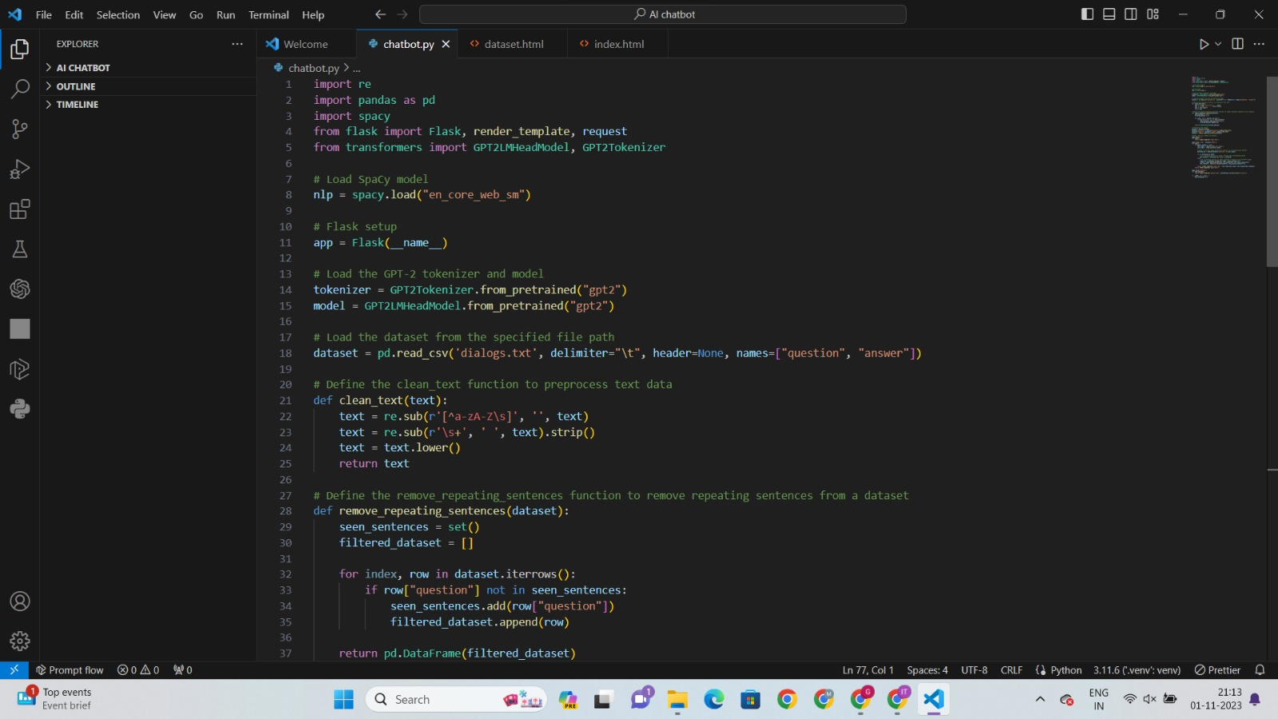

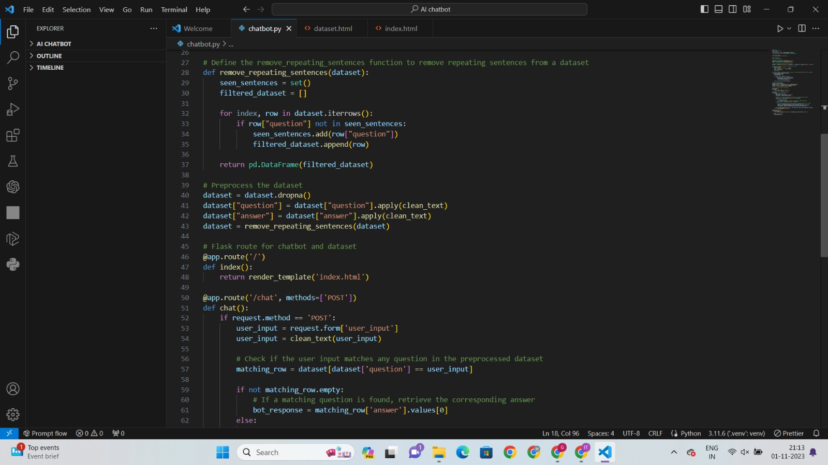

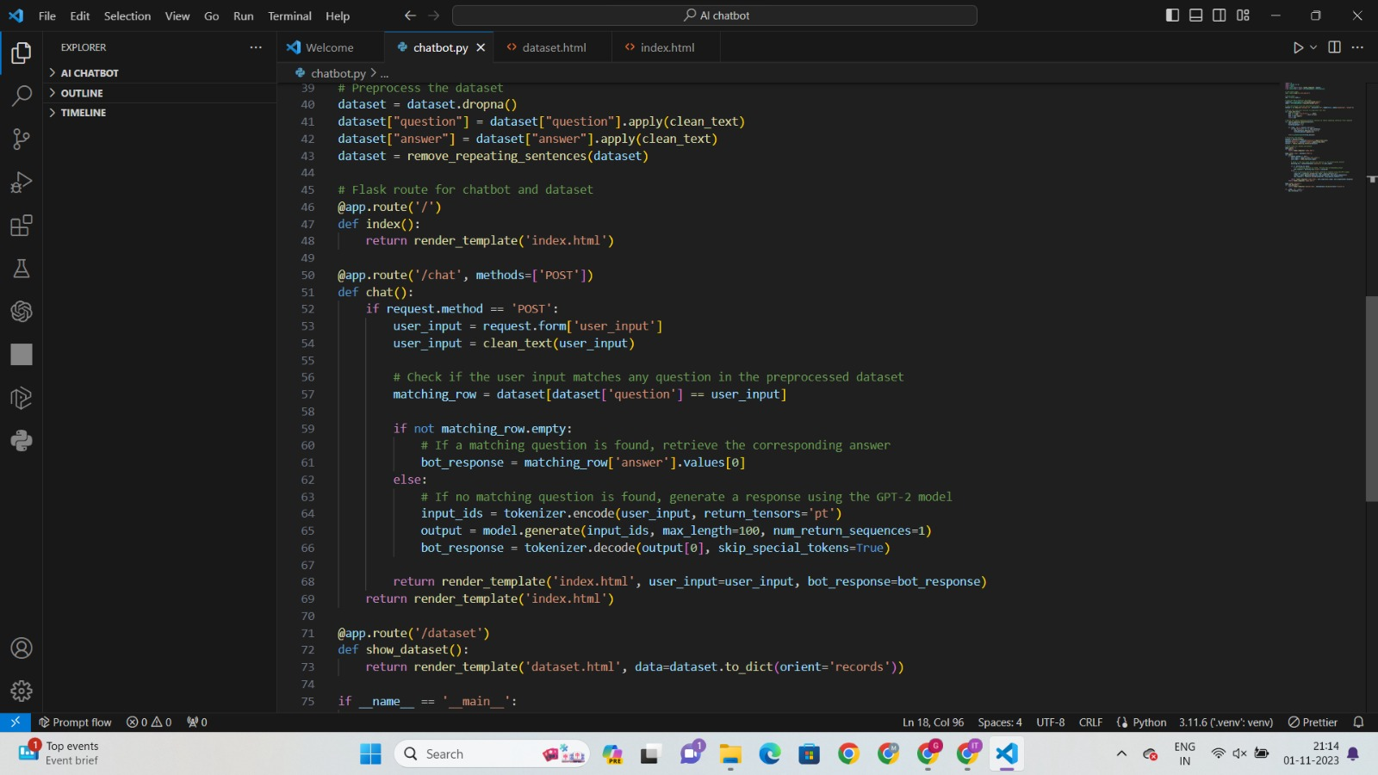

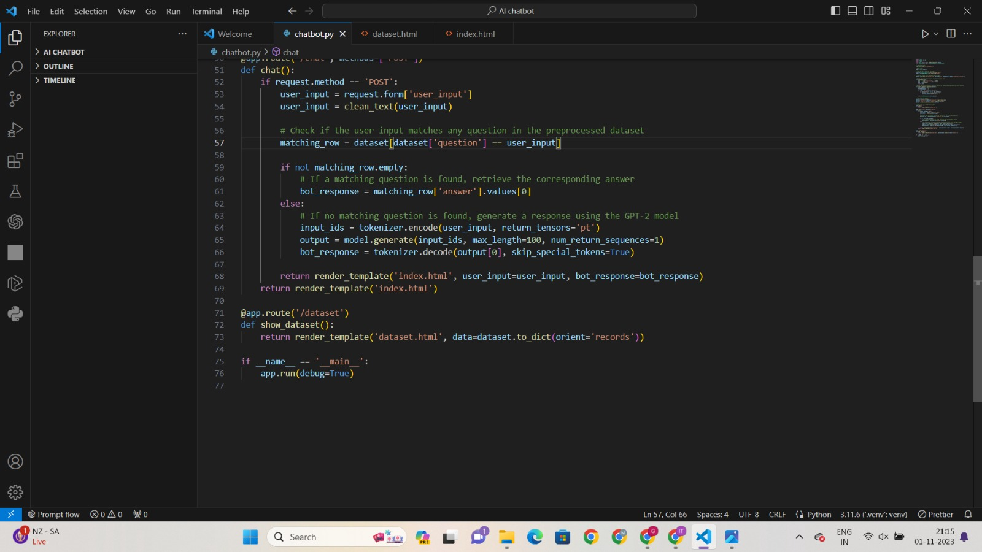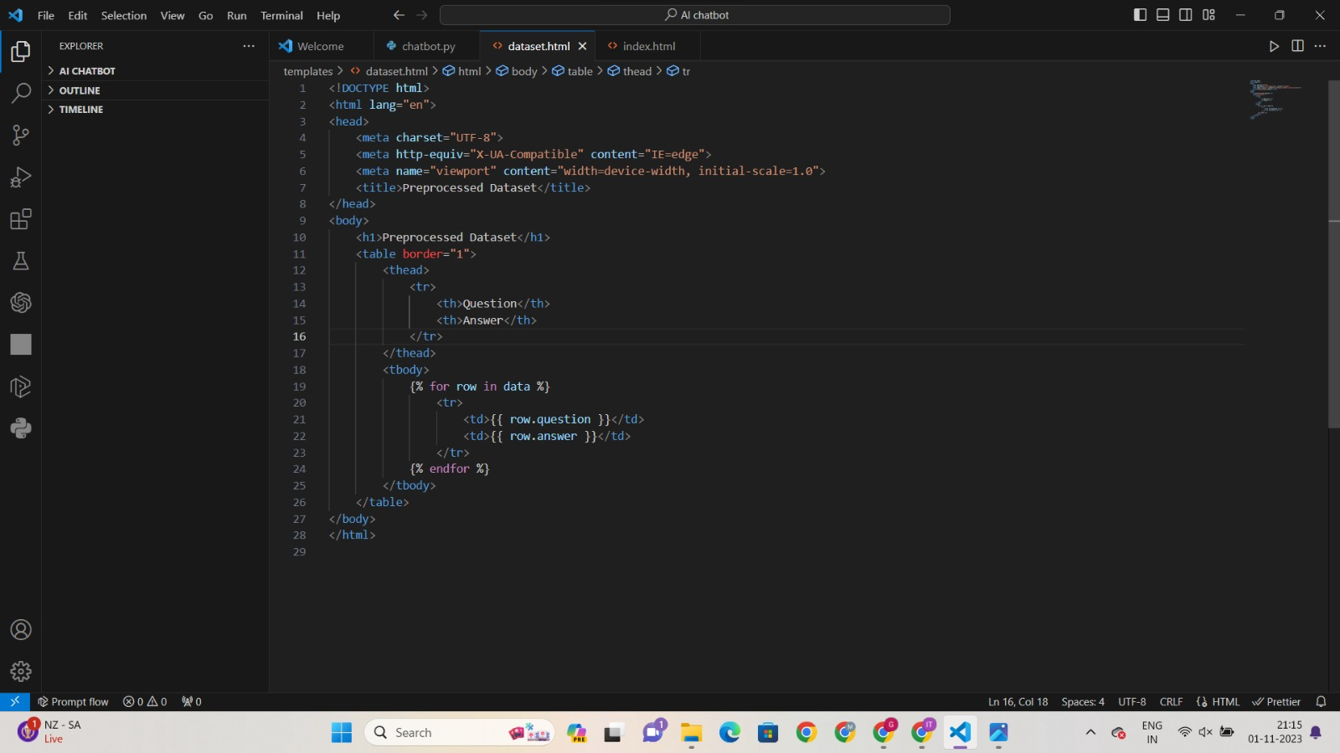

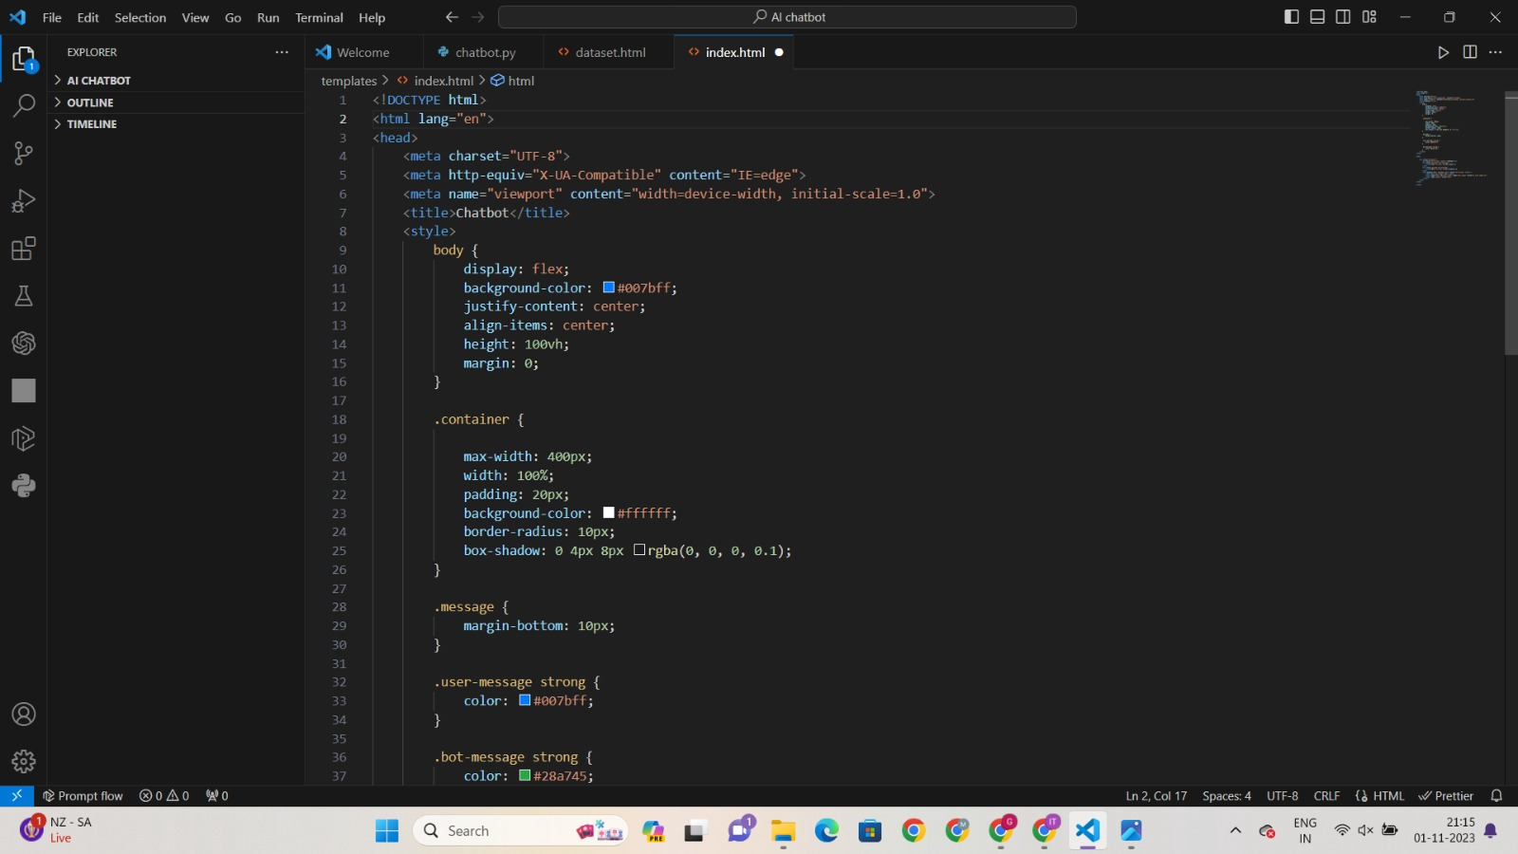

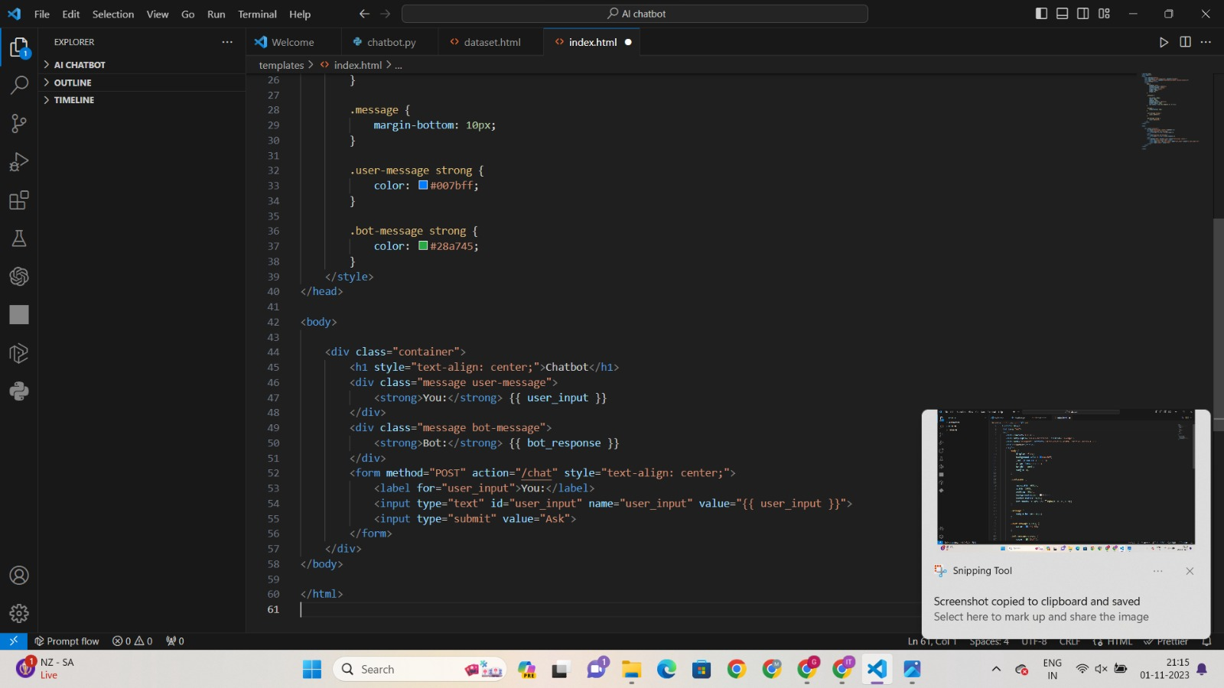

**9. CONCLUSION**

In this project, we set out to design, develop, and evaluate a Chatbot

using Python, with the goal of enhancing user interactions and

providing automated responses. The journey from the project's

inception to its completion has been both challenging and rewarding,

resulting in a functional Chatbot with promising capabilities.

**\*Key Achievements**

**i.Design and Development:** We successfully designed and implemented

a Chatbot capable of understanding and generating human-like responses

to user queries. The Chatbot combines rule-based and machine learning-based

approaches, providing a balance between predefined responses and adaptability.

**ii.Natural Language Processing:** The utilization of Python libraries,

allowed us to harness the power of natural language processing, enabling

the Chatbot to interpret and generate text in a contextually relevant manner.

**iii.User Interaction:** A user-friendly interface was created, ensuring that

users can easily interact with the Chatbot, making it accessible to a broad

audience, even those without programming knowledge.

**iv.Customization:** The Chatbot's knowledge base and responses can

be customized, making it adaptable to various applications and domains.

This feature enhances its versatility and usefulness.

**v.Performance Evaluation:** Our Chatbot was rigorously tested and

evaluated, showing promising results in terms of accuracy, response

time, and user satisfaction. Further fine-tuning and optimization can

continue to enhance its performance.